BATTLE FOR THE SOUL OF AMERICA

WHICH SIDE ARE **YOU** ON ?

Graham VS Graham



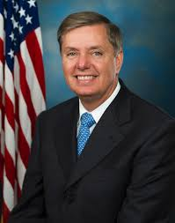

**Senator Lindsey Graham**

at first supported the 9/11 victims families’ right to sue the Saudi government, but then this boot licker of Saudi head choppers stabbed the 9/11 families in the back by leading the charge to prevent them from doing so. His treasonous defense of royals who support terrorists will keep us in a spiral of war without end, possibly triggering a war with Russia.

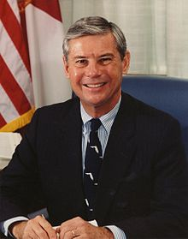

**Former Senator Bob Graham**

Is the Truth Champion who led the effort to open the 28 Pages, proving Saudi government support for the 9/11 hijackers. As former chairman of the Committee whose 28 pages were suppressed by Presidents Bush and Obama, he stated that the 28 pages show a “cover-up,” “aggressive deception,” “FBI statements untrue,” and that “the Saudi government was a co-conspirator in 9/11.”

royalsxxxxxxxxx

The Justice Against Sponsors of Terrorism Act (JASTA), passed by Congress without opposition, removes diplomatic immunity from countries supporting terrorism in the U.S. Lindsey Graham and John McCain are leading the charge to reverse this law and getting lots of media support. **Now the battle is on.** Tell Congress to STAND FIRM on JASTA! Do not allow any amendment to take place on S-2040. Become a member of the 9/11 Truth Action Project at <https://www.911tap.org/join-us/become-a-member> [www.hr14.org](http://www.hr14.org) [www.911tap.org](http://www.911tap.org) [www.dc911truth.org](http://www.dc911truth.org)

Now the battle is on.